The future of software companies 20260223
In the last month, AI news hit various industries. However, my five year perspective on software companies:
Likely be killed by AI:
- Interface strength (Quick built a similar one with function in days) - Coding based format or template (Use LLM instead of programming) - Model based on open data (No competitiveness at all in AI era) - Coding experts in specific area or industry (With difficulties of programming largely decrease, people who understand the industry will stand out if using AI correctly) - Combine sales to clients with unnecessary services (AI agent is able to use different source and vendor breaking the monopoly of software sale package)
Stimulated by AI:
- Companies with specific data (Like documents, confidential data, trust) - Compliance related - Social related (Have to use the platform when all others are using it) - Money related transactions and payment services (High switching cost and risk) - Important record hard to switch (Short term hard to be shake by AI, but companies will have to lower the price within competitions which damage profit)
Moreover, what I want share is shown in the graph below: There's still business space for AI to improve efficiency especially in legal, travel, law, etc.. In the future, we can see agent built on specific scenarios and industries that replace the position of old software.
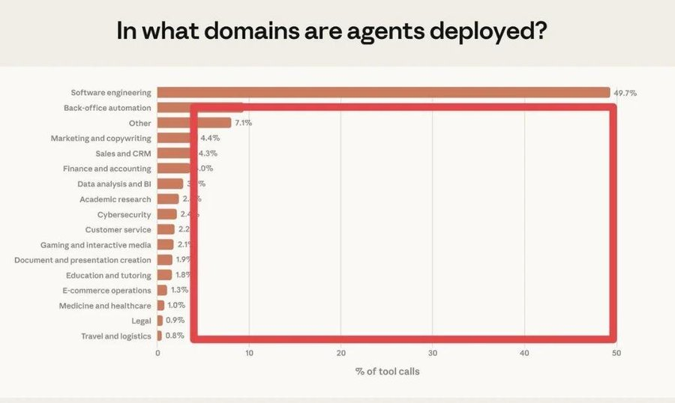

Written on 20260223 in Hong Kong. --- Xiaowen

